Data Aktarma Yolları

Import Data (en hızlısı)

Database sağ tık – tasks – import data – Microsoft excel – Microsoft OLE DB Provider for SQL Server

Excel’i "Excell 97-2003 workbook" olarak kaydet yoksa hata verir.

Aktardığın tabloya – sağ tık – design diyip int, varchar, primary key, aşağıdaki identity specification (yes)’I control et. Tools – options – designers – “prevent saving changes..” tikini kaldır. - kaydet

Kopyala yapıştır metodu (çok zaman alıyor)

Tabloya sağ tık – edit top 200 rows – Sağ yukardan  simgesine tıkla – koddaki TOP (200) ID’yi silip kodu çalıştır – başlıklar hariç kopyaladnığın değerleri aşağıdaki tabloya yapıştır.

TRUNCATE TABLE CITIES 🡪 cities table’ının içini temizler.

Excel Formulü ile (hızlı)

="INSERT INTO CITIES(CITY) VALUES ('"&B2&"')"

|  |  |  |
| --- | --- | --- |
| **ID** | **CITY** | **Column1** |
| 1 | ADANA | INSERT INTO CITIES(CITY) VALUES ('ADANA') |
| 2 | ADIYAMAN | INSERT INTO CITIES(CITY) VALUES ('ADIYAMAN') |
| 3 | AFYONKARAHİSAR | INSERT INTO CITIES(CITY) VALUES ('AFYONKARAHİSAR') |

Ardından tüm formülleri scripte kopyalayıp çalıştır.

="INSERT INTO CITIES(CITY) VALUES ("&B2&",'"&C2&"')"

|  |  |  |  |
| --- | --- | --- | --- |
| **ID** | **CITYID** | **DISTRICT** | **Column1** |
| 1 | 37 | ABANA | INSERT INTO CITIES(CITY) VALUES (37,'ABANA') |
| 2 | 20 | ACIPAYAM | INSERT INTO CITIES(CITY) VALUES (20,'ACIPAYAM') |
| 3 | 34 | ADALAR | INSERT INTO CITIES(CITY) VALUES (34,'ADALAR') |





## SENARYO 1

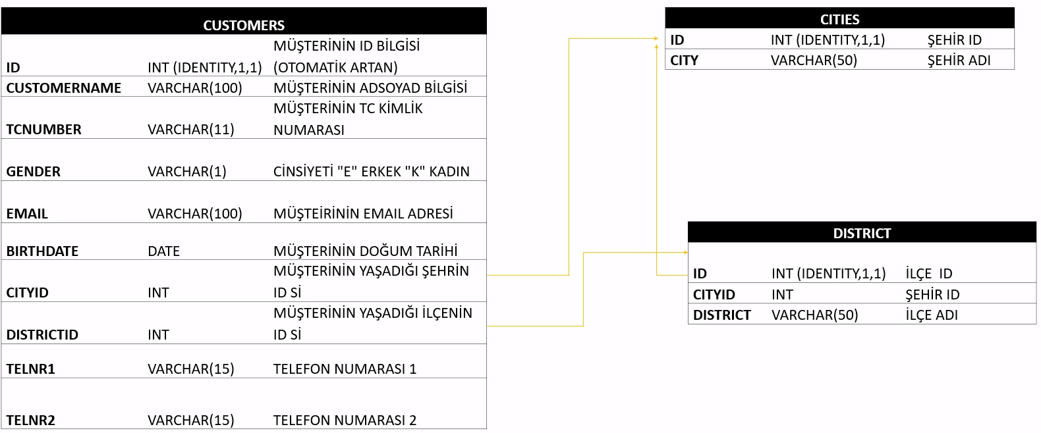

90-95 Yılları Arasında Doğanlar

SELECT * FROM CUSTOMERS

WHERE BIRTHDATE BETWEEN '1990-01-01' AND '1995-01-01'

2

SELECT * FROM CUSTOMERS

WHERE YEAR(BIRTHDATE) BETWEEN 1990 AND 1995

Şubatta doğanlar

SELECT * FROM CUSTOMERS

WHERE MONTH(BIRTHDATE)='02'

Seçili kişiyle aynı doğum günü olanlar

SELECT * FROM CUSTOMERS

WHERE DAY(BIRTHDATE)=DATEPART(DAY,'1985-02-11') AND MONTH(BIRTHDATE)=DATEPART(MONTH,'1985-02-11')

İstanbulda yaşayanları bulma (tabloda ID’yi tekrar yazmadan)

SELECT c.*,ct.CITY FROM CUSTOMERS c

JOIN CITIES ct ON c.CITYID=ct.ID

WHERE CITY='İSTANBUL'

2 (subquery yardımıyla tabloda şehri başa yazarak)

SELECT (SELECT CITY FROM CITIES WHERE C.CITYID=CITIES.ID),*

FROM CUSTOMERS C

WHERE (SELECT CITY FROM CITIES WHERE C.CITYID=CITIES.ID)='İSTANBUL'

Hangi şehirde kaç müşteri var

SELECT CITY CT,COUNT(*) FROM CITIES

JOIN CUSTOMERS C ON CITIES.ID=C.CITYID

GROUP BY CITY

Not: GROUP BY Kullanacaksan koşulu Where ile belirleyemezsin. Having kullanmak gerekir.

Tabloları algılamıyorsa so lüstten hangi database’in seçildiğini control et.



SELECT CITY,COUNT(*) FROM CITIES CT

JOIN CUSTOMERS C ON C.CITYID=CT.ID

GROUP BY CITY

HAVING COUNT(*)>10

ORDER BY 2 DESC

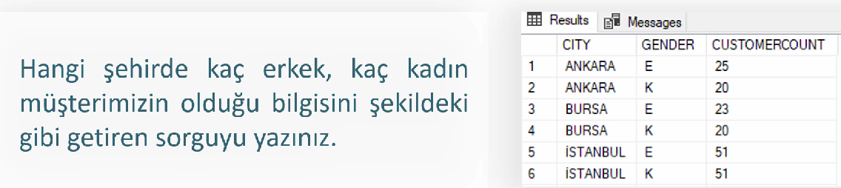

SELECT CITY, GENDER, COUNT(*) FROM CITIES CT

JOIN CUSTOMERS C ON CT.ID=C.CITYID

GROUP BY CITY, GENDER

ORDER BY 1,2

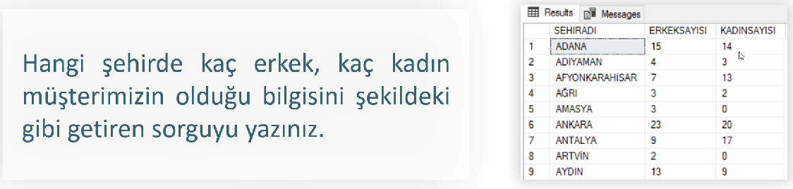

SELECT CITY AS SEHIRADI,

(SELECT COUNT(*) FROM CUSTOMERS WHERE CITYID=CT.ID AND GENDER='E') AS ERKEKSAYISI,

(SELECT COUNT(*) FROM CUSTOMERS WHERE CITYID=CT.ID AND GENDER='K') AS KADINSAYISI

FROM CITIES CT

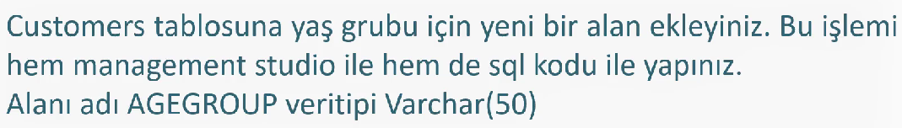

ALTER TABLE CUSTOMERS

ADD AGEGROUP varchar(50)

2

Tabloya sağ tık – design – ekle - kaydet

Tablodan çıkarma

ALTER TABLE CUSTOMERS

DROP COLUMN AGEGORUP

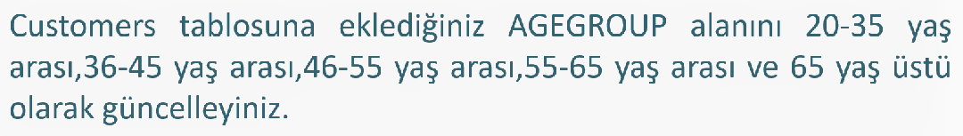

UPDATE CUSTOMERS SET AGEGROUP='20-35 YAŞ'

WHERE (DATEDIFF(YEAR,BIRTHDATE,GETDATE())) BETWEEN 20 AND 35

UPDATE CUSTOMERS SET AGEGROUP='36-45 YAŞ'

WHERE (DATEDIFF(YEAR,BIRTHDATE,GETDATE())) BETWEEN 36 AND 45

UPDATE CUSTOMERS SET AGEGROUP='46-55 YAŞ'

WHERE (DATEDIFF(YEAR,BIRTHDATE,GETDATE())) BETWEEN 46 AND 55

UPDATE CUSTOMERS SET AGEGROUP='56-65 YAŞ'

WHERE (DATEDIFF(YEAR,BIRTHDATE,GETDATE())) BETWEEN 56 AND 65

UPDATE CUSTOMERS SET AGEGROUP='65 YAŞ ÜSTÜ'

WHERE (DATEDIFF(YEAR,BIRTHDATE,GETDATE())) > 65

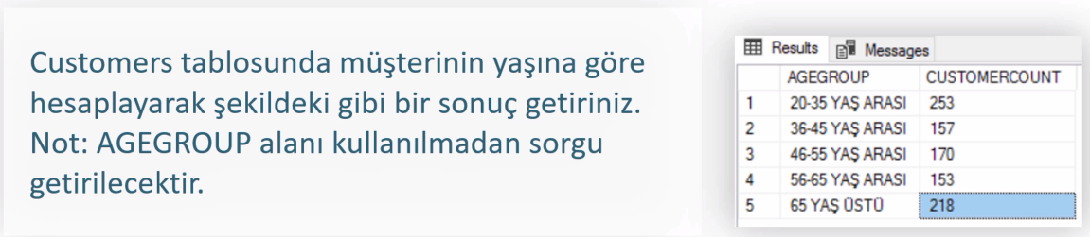

SELECT AGEGROUP, COUNT(*) FROM CUSTOMERS AS CUSTOMERCOUNT

GROUP BY AGEGROUP

ORDER BY 1

2 (AGEGROUP kullanmadan)

SELECT

CASE

WHEN DATEDIFF(YEAR,BIRTHDATE,GETDATE()) BETWEEN 20 AND 35 THEN '20-35 YAŞ'

WHEN DATEDIFF(YEAR,BIRTHDATE,GETDATE()) BETWEEN 36 AND 45 THEN '36-45 YAŞ'

WHEN DATEDIFF(YEAR,BIRTHDATE,GETDATE()) BETWEEN 40 AND 55 THEN '46-55 YAŞ'

WHEN DATEDIFF(YEAR,BIRTHDATE,GETDATE()) BETWEEN 56 AND 65 THEN '56-65 YAŞ'

WHEN DATEDIFF(YEAR,BIRTHDATE,GETDATE()) >65 THEN '65 YAŞ ÜSTÜ'

END AGEGROUP2,

COUNT(*) AS CUSTOMERCOUNT

FROM CUSTOMERS

GROUP BY

CASE

WHEN DATEDIFF(YEAR,BIRTHDATE,GETDATE()) BETWEEN 20 AND 35 THEN '20-35 YAŞ'

WHEN DATEDIFF(YEAR,BIRTHDATE,GETDATE()) BETWEEN 36 AND 45 THEN '36-45 YAŞ'

WHEN DATEDIFF(YEAR,BIRTHDATE,GETDATE()) BETWEEN 40 AND 55 THEN '46-55 YAŞ'

WHEN DATEDIFF(YEAR,BIRTHDATE,GETDATE()) BETWEEN 56 AND 65 THEN '56-65 YAŞ'

WHEN DATEDIFF(YEAR,BIRTHDATE,GETDATE()) >65 THEN '65 YAŞ ÜSTÜ'

END

ORDER BY 1

3 (AGEGROUP’u GROUP BY gibi farklı yerlerde kullanmak için)

SELECT AGEGROUP2,COUNT(*) AS CUSTOMERCOUNT FROM

(SELECT *,

CASE

WHEN DATEDIFF(YEAR,BIRTHDATE,GETDATE()) BETWEEN 20 AND 35 THEN '20-35 YAŞ'

WHEN DATEDIFF(YEAR,BIRTHDATE,GETDATE()) BETWEEN 36 AND 45 THEN '36-45 YAŞ'

WHEN DATEDIFF(YEAR,BIRTHDATE,GETDATE()) BETWEEN 40 AND 55 THEN '46-55 YAŞ'

WHEN DATEDIFF(YEAR,BIRTHDATE,GETDATE()) BETWEEN 56 AND 65 THEN '56-65 YAŞ'

WHEN DATEDIFF(YEAR,BIRTHDATE,GETDATE()) >65 THEN '65 YAŞ ÜSTÜ'

END AGEGROUP2 FROM CUSTOMERS) TMP

GROUP BY AGEGROUP2

ORDER BY AGEGROUP2



SELECT CUSTOMERNAME FROM CUSTOMERS C

JOIN DISTRICTS D ON C.DISTRICTID=D.ID

JOIN CITIES CT ON CT.ID=C.CITYID

WHERE CITY='İSTANBUL' AND DISTRICT!='KADIKÖY'

Son Satırın Alternatifleri:

WHERE CITY='İSTANBUL' AND DISTRICT<>'KADIKÖY'

WHERE CITY='İSTANBUL' AND DISTRICT NOT LIKE 'KADIKÖY'

WHERE CITY='İSTANBUL' AND DISTRICT NOT IN ('KADIKÖY')

WHERE CITY='İSTANBUL' AND NOT DISTRICT='KADIKÖY'

2

SELECT CUSTOMERNAME FROM CUSTOMERS C

WHERE CITYID IN (SELECT ID FROM CITIES WHERE CITY='İSTANBUL')

AND DISTRICTID NOT IN (SELECT ID FROM DISTRICTS WHERE DISTRICT='KADIKÖY')

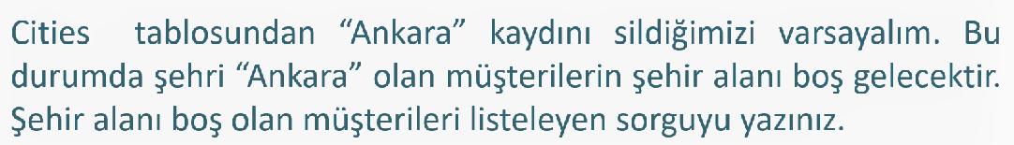

Ankara’yı sil:

DELETE FROM CITIES WHERE CITY='ANKARA'

SELECT CUSTOMERNAME FROM CUSTOMERS C

LEFT JOIN CITIES CT ON CT.ID=C.CITYID

WHERE CITY IS NULL

Ankara’yı geri ekle:

SET IDENTITY_INSERT CITIES ON

INSERT INTO CITIES(ID,CITY)

VALUES (6, 'ANKARA')

SET IDENTITY_INSERT CITIES OFF

Ankara’yı değiştir (Ankara yerine ANKARA):

UPDATE CITIES

SET CITY = 'ANKARA'

WHERE ID = 6

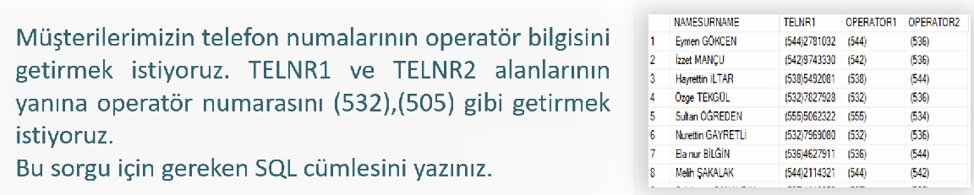

SELECT *,SUBSTRING(TELNR1,2,3) AS OPERATOR1

,SUBSTRING(TELNR2,2,3) AS OPERATOR2

FROM CUSTOMERS

Belirli bir yeri alma (substringte 2.ye nerden başladığı, 3.ye kaç karakter alacağı)

SELECT SUBSTRING('5375599906',1,3)

SELECT LEFT('5375599906',3)

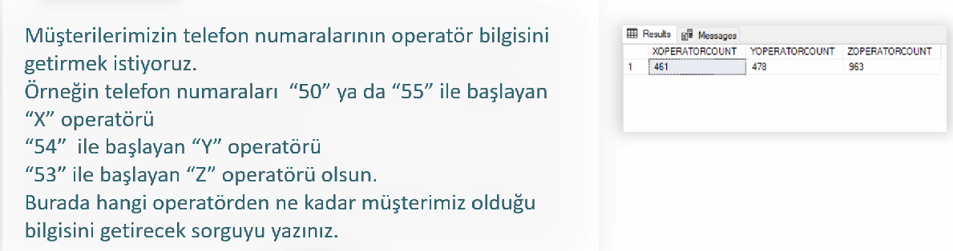

SELECT

SUM(CASE WHEN SUBSTRING(TELNR1, 3, 2) IN (50, 55) THEN 1

WHEN SUBSTRING(TELNR2, 3, 2) IN (50, 55) THEN 1 ELSE 0 END) AS OPERATOR_X,

SUM(CASE WHEN SUBSTRING(TELNR1, 3, 2) = 54 THEN 1

WHEN SUBSTRING(TELNR2, 3, 2) = 54 THEN 1 ELSE 0 END) AS OPERATOR_Y,

SUM(CASE WHEN SUBSTRING(TELNR1, 3, 2) = 53 THEN 1

WHEN SUBSTRING(TELNR2, 3, 2) = 53 THEN 1 ELSE 0 END) AS OPERATOR_Z

FROM CUSTOMERS

2

SELECT

COUNT(CASE WHEN SUBSTRING(TELNR1, 3, 2) IN (50, 55) OR SUBSTRING(TELNR2, 3, 2) IN (50, 55) THEN 1 END) AS OPERATOR_X,

COUNT(CASE WHEN SUBSTRING(TELNR1, 3, 2) = 54 OR SUBSTRING(TELNR2, 3, 2) = 54 THEN 1 END) AS OPERATOR_Y,

COUNT(CASE WHEN SUBSTRING(TELNR1, 3, 2) = 53 OR SUBSTRING(TELNR2, 3, 2) = 53 THEN 1 END) AS OPERATOR_Z

FROM CUSTOMERS

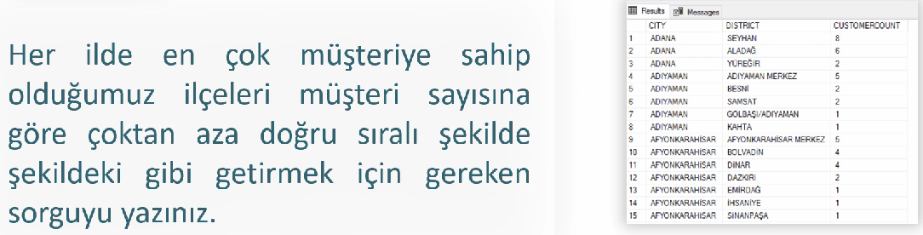

SELECT

(SELECT CITY FROM CITIES CT WHERE CT.ID = C.CITYID) AS CITY,

(SELECT DISTRICT FROM DISTRICTS D WHERE D.ID = C.DISTRICTID) AS DISTRICT,

COUNT(*) AS CUSTOMER_COUNT

FROM CUSTOMERS C

GROUP BY C.CITYID, C.DISTRICTID

ORDER BY 1,2

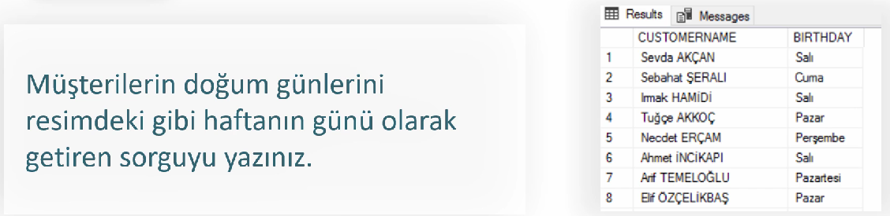

SET LANGUAGE Turkish

SELECT CUSTOMERNAME, DATENAME(DW,BIRTHDATE) AS BIRTHDAY

FROM CUSTOMERS

DW haftanın gününü, day günü, month ayı, year yılı verir.

Haftanın kaç nolu gününe denk geldiğini bulmak için:

SELECT

DATEPART(DAY,BIRTHDATE), BIRTHDATE

FROM CUSTOMERS



SELECT CUSTOMERNAME

FROM CUSTOMERS

WHERE MONTH(BIRTHDATE)=MONTH(GETDATE()) AND

DAY(BIRTHDATE)=DAY(GETDATE())

2

SELECT CUSTOMERNAME

FROM CUSTOMERS

WHERE DATEPART(MONTH,BIRTHDATE)=DATEPART(MONTH,GETDATE()) AND

DATEPART(DAY,BIRTHDATE)=DATEPART(DAY,GETDATE())

## SENARYO 2

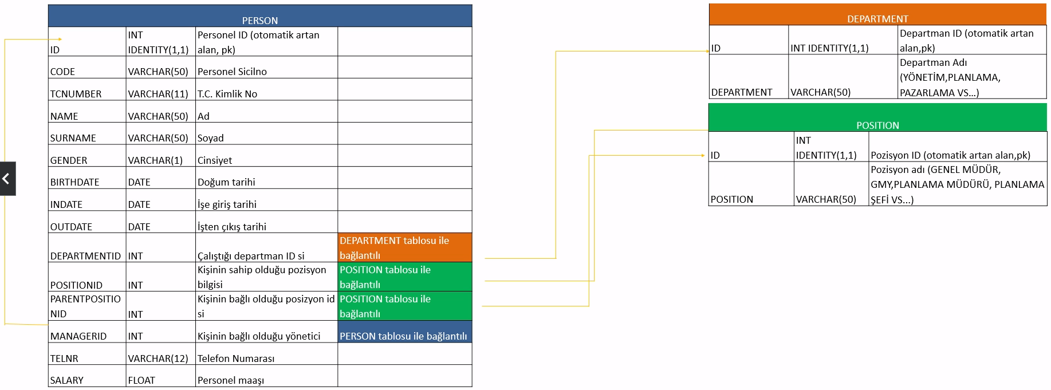

OUTDATE’in NULL olması çalışanın hala çalıştığını gösteriyor.

MANAGERID tablosundaki bazı değerler excelde NULL yazıldığı için SQL’de int’e çevrilemiyor. Çözüm için;

1. Excel’de NULL yazan yerleri boş bırak.
2. SQL’de aşağıdaki kodu uygula:

UPDATE PERSON

SET MANAGERID = NULL

WHERE MANAGERID = 'NULL'



SELECT NAME_+' '+SURNAME AS EMPLOYEE

FROM PERSON

WHERE OUTDATE IS NULL

=NULL ibaresi kullanılmaz. IS NULL olmalı.

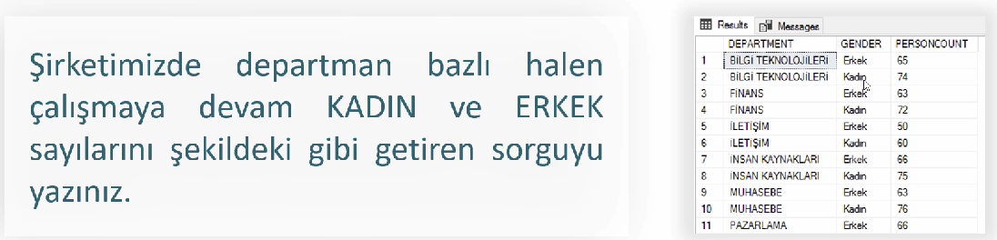

SELECT DEPARTMENT,

CASE WHEN GENDER='E' THEN 'Erkek'

WHEN GENDER='K' THEN 'Kadın' END AS GENDER,

COUNT(*) AS EMPLOYEE_COUNT

FROM PERSON P JOIN DEPARTMENT D ON P.DEPARTMENTID=D.ID

GROUP BY DEPARTMENT, GENDER

ORDER BY 1,2

Doğrudan GENDER üzerinden işlem yaptığımız için ORDER BY’a GENDER yazabiliyoruz. GENDER’ın ilk harfini falan alıp işlem yapmıyoruz. Aksi halde CASE li ifadeyi tekrar yazmamaız gerekecekti.

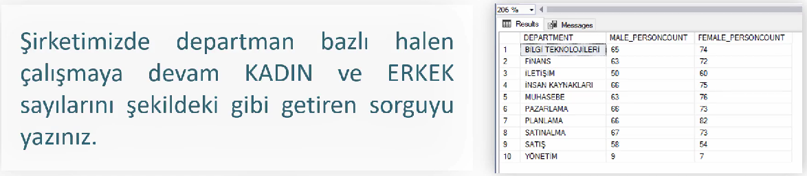

Sütunlara göre ayrım yapıyorsan subquery kullanılıyor gibi. Satırlara göre ise Group By.

SELECT DEPARTMENT,

(SELECT COUNT(*) FROM PERSON P WHERE P.DEPARTMENTID=D.ID AND GENDER='E' AND OUTDATE IS NULL) AS MALES,

(SELECT COUNT(*) FROM PERSON P WHERE P.DEPARTMENTID=D.ID AND GENDER='K' AND OUTDATE IS NULL) AS FEMALES

FROM DEPARTMENT D

ORDER BY 1

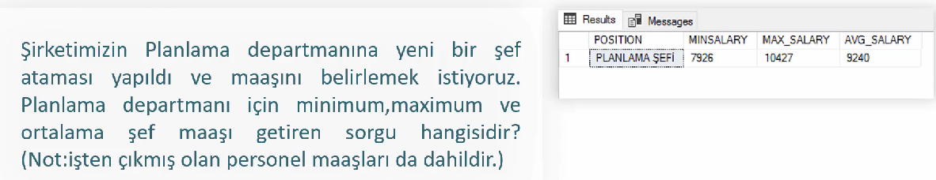

SELECT POSITION,

MIN(SALARY) AS MIN_SALARY,

MAX(SALARY) AS MAX_SALARY,

ROUND(AVG(SALARY),0) AS AVG_SALARY

FROM PERSON P JOIN POSITION PS ON P.POSITIONID=PS.ID

WHERE POSITION='PLANLAMA ŞEFİ'

GROUP BY POSITION

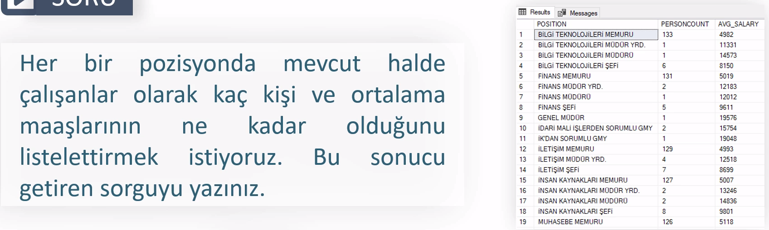

SELECT POSITION,

COUNT(*) AS PERSONCOUNT,

ROUND(AVG(SALARY),0) AS AVG_SALARY

FROM POSITION P JOIN PERSON PS ON P.ID=PS.POSITIONID

WHERE OUTDATE IS NULL

GROUP BY POSITION

2

SELECT POSITION,

(SELECT COUNT(*) FROM PERSON PS WHERE P.ID=PS.POSITIONID AND OUTDATE IS NULL) AS PERSONCOUNT,

(SELECT ROUND(AVG(SALARY),0) FROM PERSON PS WHERE P.ID=PS.POSITIONID AND OUTDATE IS NULL) AS AVG_SALARY

FROM POSITION P

ORDER BY 1

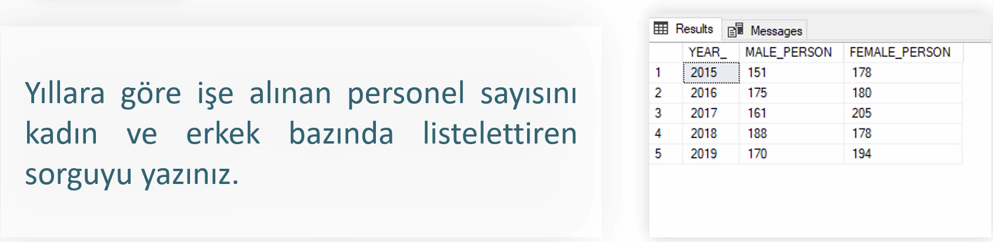

SELECT DISTINCT YEAR(INDATE) AS YEAR,

(SELECT COUNT(*) FROM PERSON P2 WHERE GENDER='E' AND YEAR(P.INDATE)=YEAR(P2.INDATE)) AS MALES,

(SELECT COUNT(*) FROM PERSON P3 WHERE GENDER='K' AND YEAR(P.INDATE)=YEAR(P3.INDATE)) AS FEMALES

FROM PERSON P

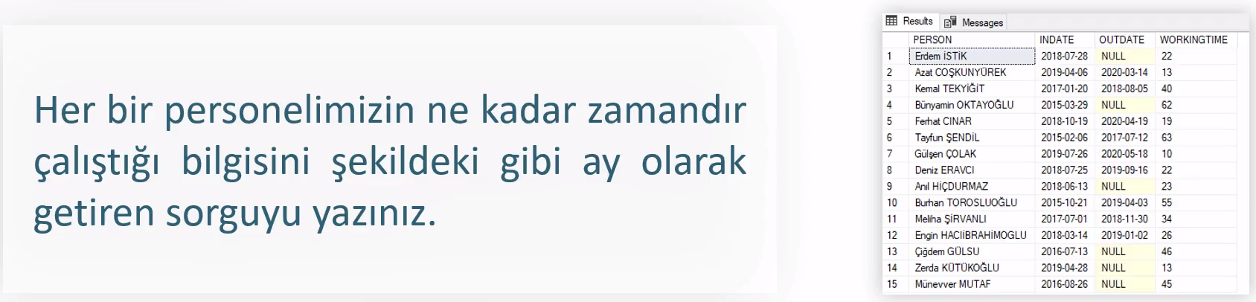

SELECT NAME_+' '+SURNAME AS EMPLOYEE, INDATE, OUTDATE,

CASE WHEN OUTDATE IS NOT NULL THEN DATEDIFF(MONTH,INDATE,OUTDATE)

ELSE DATEDIFF(MONTH,INDATE,GETDATE()) END AS WORKINGTIME

FROM PERSON

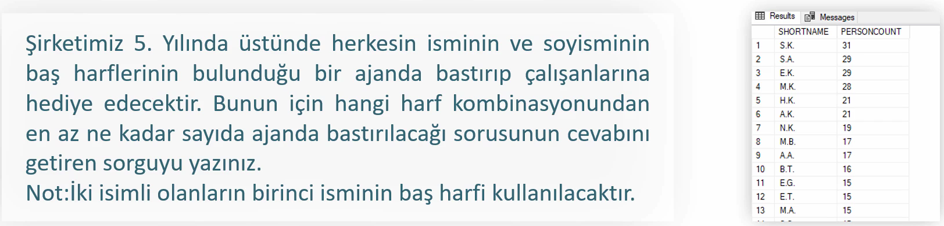

SELECT

SUBSTRING(NAME_,1,1)+'.'+SUBSTRING(SURNAME,1,1)+'.' AS SHORTNAME,

COUNT(*) AS PERSONCOUNT

FROM PERSON

GROUP BY SUBSTRING(NAME_,1,1),SUBSTRING(SURNAME,1,1)

ORDER BY COUNT(*) DESC

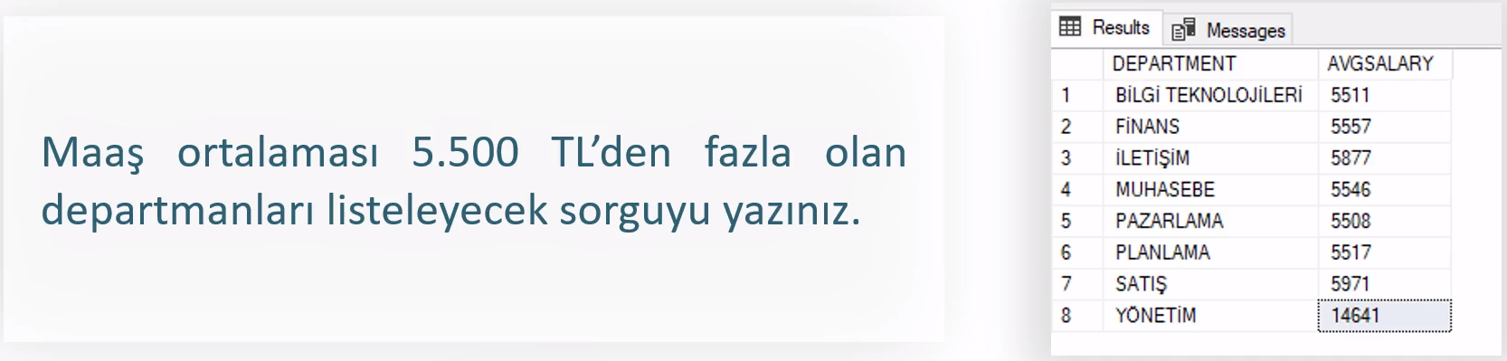

Subquery kullanıyorsan koşulu ayrı bir Where komutuyla yaz.

Group by kullanıyorsan Having ile yaz.

SELECT DEPARTMENT,

(SELECT ROUND(AVG(SALARY),0) FROM PERSON P

WHERE P.DEPARTMENTID=DEPARTMENT.ID) AS AVG_SALARY

FROM DEPARTMENT

WHERE (SELECT AVG(SALARY) FROM PERSON P WHERE P.DEPARTMENTID=DEPARTMENT.ID)>5500

2

SELECT DEPARTMENT, ROUND(AVG(SALARY),0) AS AVG_SALARY

FROM DEPARTMENT D JOIN PERSON P ON D.ID=DEPARTMENTID

GROUP BY DEPARTMENT

HAVING AVG(SALARY)>5500

3

SELECT * FROM (

SELECT DEPARTMENT, ROUND(AVG(SALARY),0) AS AVG_SALARY

FROM DEPARTMENT D

JOIN PERSON P ON D.ID=DEPARTMENTID

GROUP BY DEPARTMENT) T

WHERE AVG_SALARY>5500

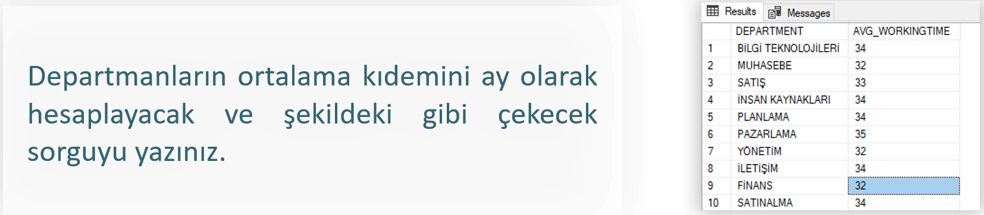

SELECT DEPARTMENT,

AVG(CASE WHEN OUTDATE IS NULL THEN DATEDIFF(MONTH, INDATE, GETDATE())

ELSE DATEDIFF(MONTH, INDATE, OUTDATE) END) AS AVG_WORKINGTIME

FROM DEPARTMENT D JOIN PERSON P ON D.ID = P.DEPARTMENTID

GROUP BY DEPARTMENT

2

SELECT DEPARTMENT,AVG(WORKINGTIME) AS AVG_WORKINGTIME FROM

(SELECT DEPARTMENT,

CASE WHEN OUTDATE IS NULL THEN DATEDIFF(MONTH,INDATE,GETDATE())

ELSE DATEDIFF(MONTH,INDATE,OUTDATE) END WORKINGTIME

FROM DEPARTMENT D JOIN PERSON P ON D.ID=DEPARTMENTID) T

GROUP BY DEPARTMENT

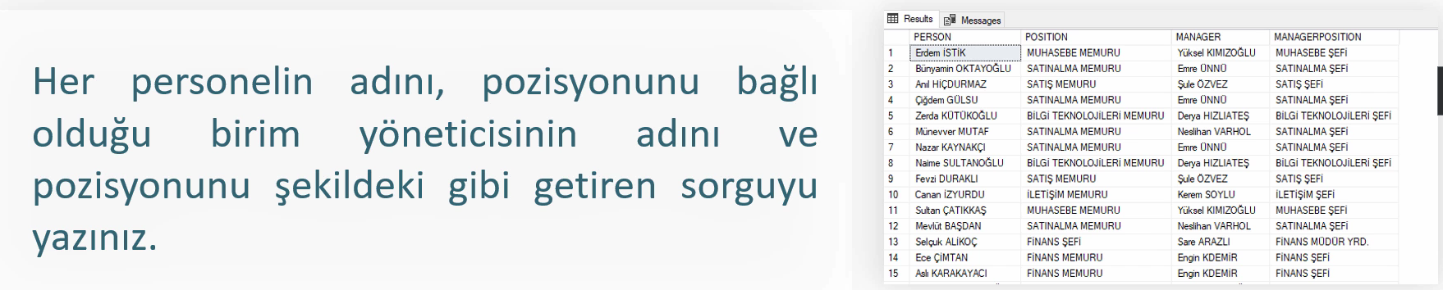

Ben böyle yaptım. Manager’I null olanlar da dahil:

SELECT NAME_+' '+SURNAME AS EMPLOYEE, POSITION,

(SELECT NAME_+' '+SURNAME FROM PERSON P2 WHERE P2.ID=P.MANAGERID) AS MANAGER,

(SELECT POSITION FROM POSITION PS WHERE MANAGERID IS NOT NULL AND P.POSITIONID=PS.ID) AS MANAGERPOSITION

FROM PERSON P JOIN POSITION PS ON POSITIONID=PS.ID

ORDER BY 2

Kendisi manager null olanları almamış:

SELECT

P.NAME_+' '+P.SURNAME AS EMPLOYEE, PS.POSITION,

P2.NAME_+' '+P2.SURNAME AS MANAGER, PS2.POSITION AS MANAGERPOSITION

FROM PERSON P

JOIN POSITION PS ON PS.ID=P.POSITIONID

JOIN PERSON P2 ON P.MANAGERID=P2.ID

JOIN POSITION PS2 ON PS2.ID=P2.POSITIONID

ORDER BY 2

## SENARYO 3

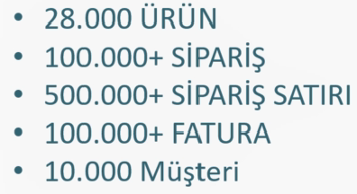 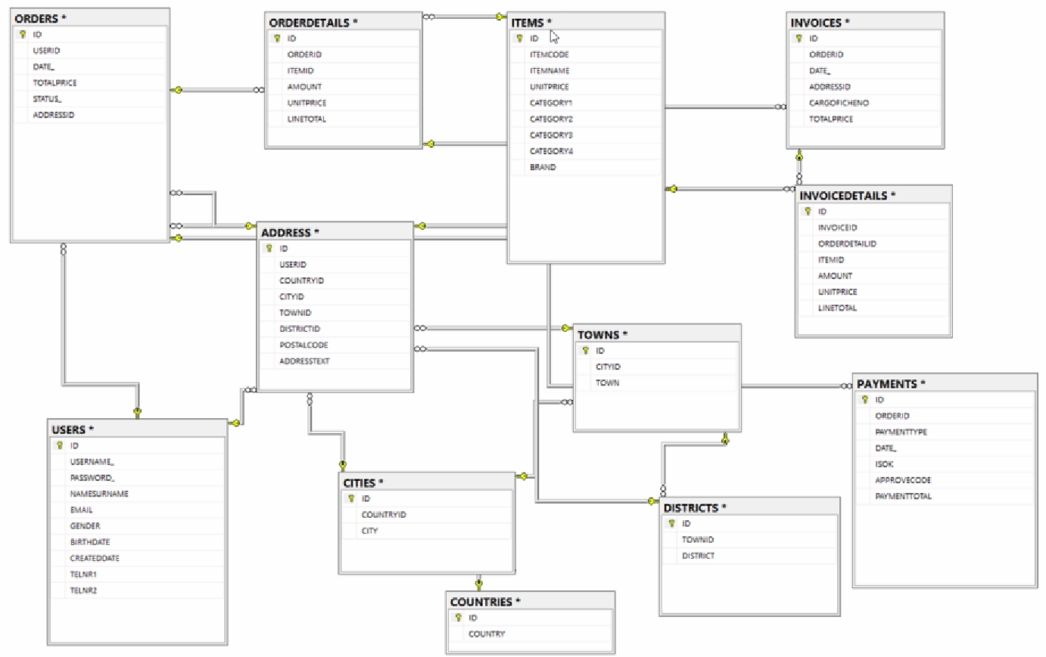.BAK uzantılı table transferi için Database’e sağ tık, Restore Database, Device’tan uzantıyı ekle.

01.PZT 🡪 Pazartesi

UPDATE SALEORDERS SET DAYOFWEEK_='Pazartesi' WHERE DAYOFWEEK_='01.PZT'

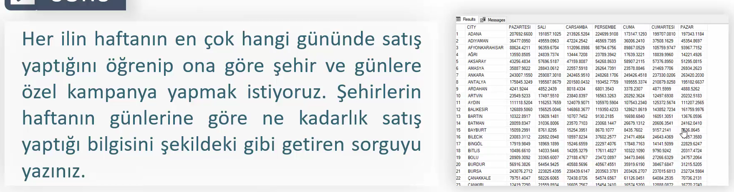

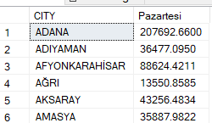SELECT CITY, (SELECT SUM(LINETOTAL) FROM SALEORDERS WHERE CITY=S.CITY AND DAYOFWEEK_='Pazartesi') as Pazartesi

FROM SALEORDERS S

GROUP BY CITY

ORDER BY 1

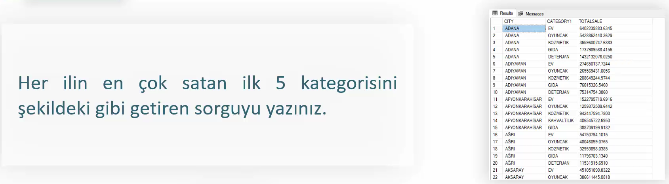

Uzun uzun unionla istediklerini gösterebilirsin:

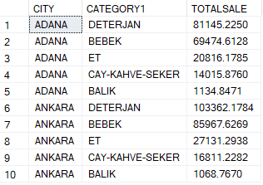SELECT TOP 5 CITY, CATEGORY1, SUM(LINETOTAL) TOTALSALE

FROM SALEORDERS

WHERE CITY='ADANA'

GROUP BY CITY, CATEGORY1

UNION ALL

SELECT TOP 5 CITY, CATEGORY1, SUM(LINETOTAL) TOTALSALE

FROM SALEORDERS

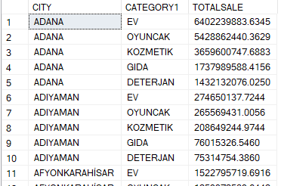WHERE CITY='ANKARA'

GROUP BY CITY, CATEGORY1

ORDER BY 1,3 DESC

Çözüm:

SELECT S.CITY, S1.CATEGORY1, SUM(S1.TOTALSALE) TOTALSALE

FROM SALEORDERS S

CROSS APPLY (SELECT TOP 5 CATEGORY1, SUM(LINETOTAL) AS TOTALSALE FROM SALEORDERS WHERE CITY=S.CITY GROUP BY CATEGORY1 ORDER BY 2 DESC) S1

GROUP BY S.CITY, S1.CATEGORY1

ORDER BY S.CITY, SUM(S1.TOTALSALE) DESC

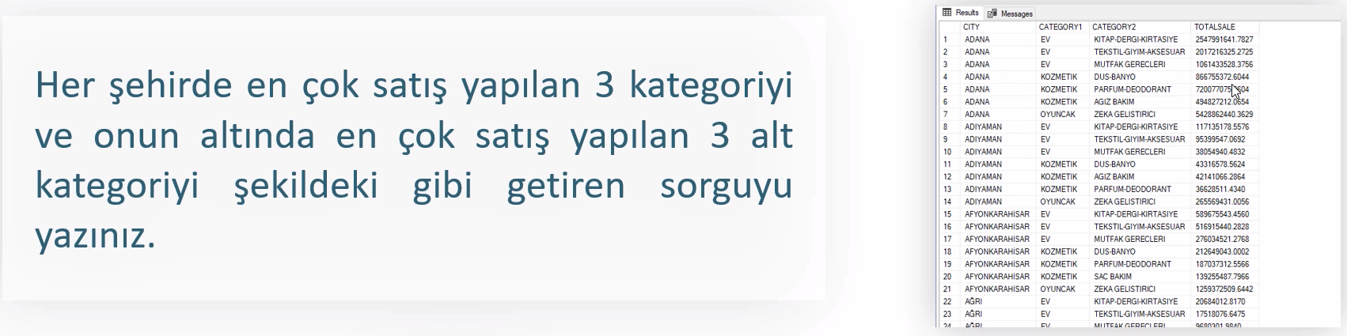

SELECT S.CITY, S1.CATEGORY1, S2.CATEGORY2, SUM(S1.TOTALSALE) TOTALSALE

FROM SALEORDERS S

CROSS APPLY (SELECT TOP 3 CATEGORY1, SUM(LINETOTAL) AS TOTALSALE FROM SALEORDERS WHERE CITY=S.CITY GROUP BY CATEGORY1 ORDER BY 2 DESC) S1

CROSS APPLY (SELECT TOP 3 CATEGORY2, SUM(LINETOTAL) AS TOTALSALE FROM SALEORDERS WHERE CITY=S.CITY GROUP BY CATEGORY2 ORDER BY 2 DESC) S2

GROUP BY S.CITY, S1.CATEGORY1, S2.CATEGORY2

ORDER BY S.CITY, SUM(S1.TOTALSALE) DESC

Cities tablosunu kopyalayarak tablo oluşturma:

SELECT * INTO CITIES2 FROM CITIES

Ctrl+h 🡪 Mesela seçili yerdeki tüm [ leri boşlukla değiştirebilirsin.

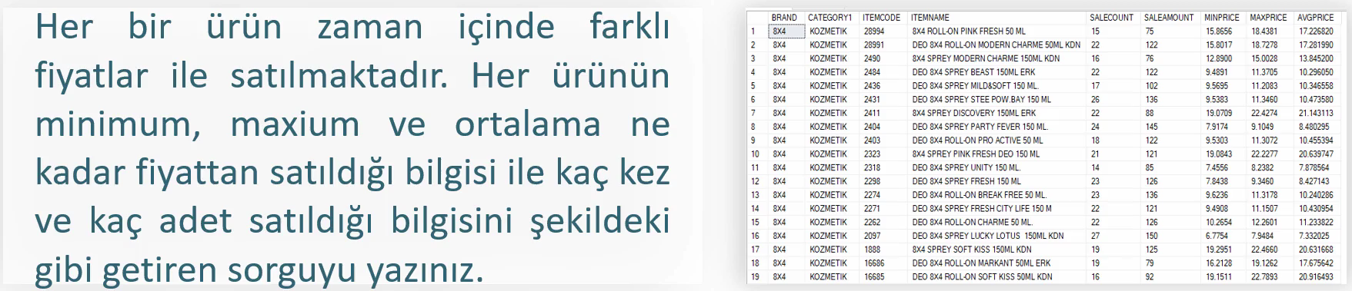

SELECT ITM.BRAND, ITM.CATEGORY1, ITM.ITEMCODE, ITM.ITEMNAME, COUNT(OD.ID) AS SALECOUNT,

SUM(OD.AMOUNT) AS SALEAMOUNT, MIN(OD.UNITPRICE) AS MINPRICE, MAX(OD.UNITPRICE) AS MAXPRICE, AVG(OD.UNITPRICE) AS AVGPRICE

FROM ITEMS ITM

JOIN ORDERDETAILS OD ON OD.ITEMID=ITM.ID

GROUP BY ITM.BRAND, ITM.CATEGORY1, ITM.ITEMCODE, ITM.ITEMNAME

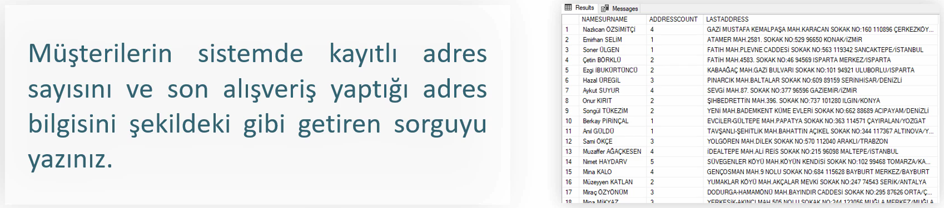

## SENARYO 4

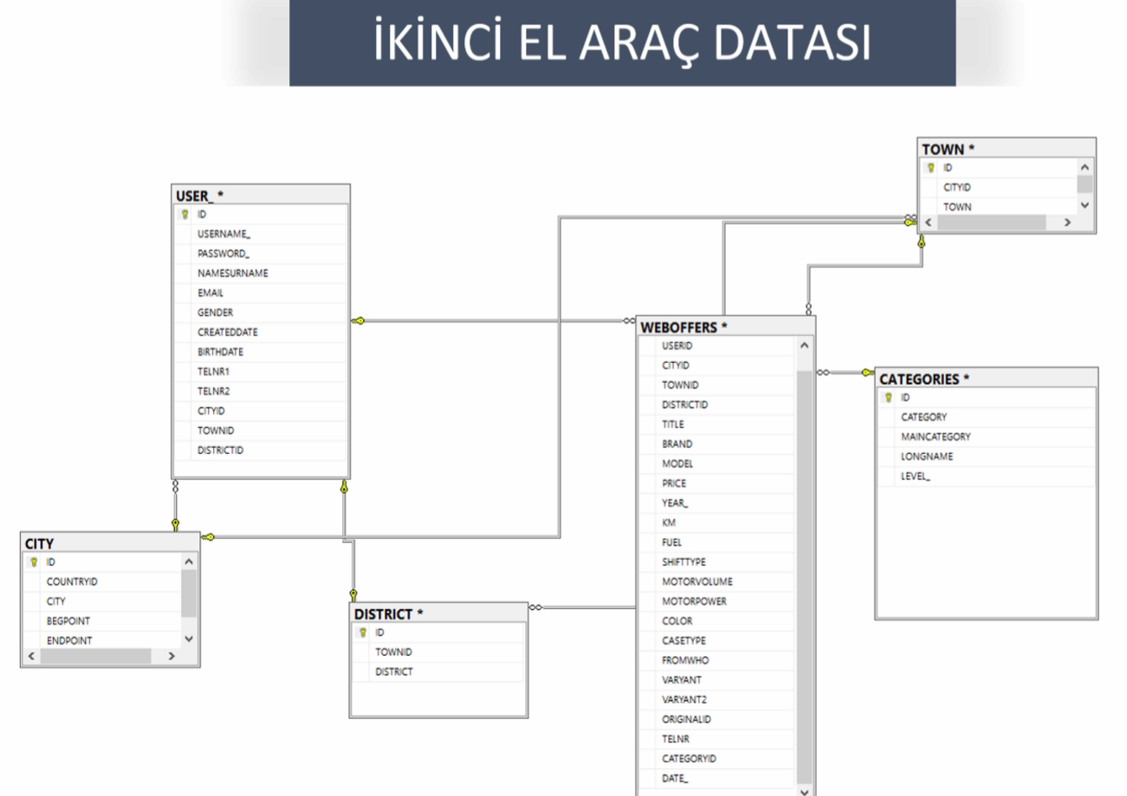

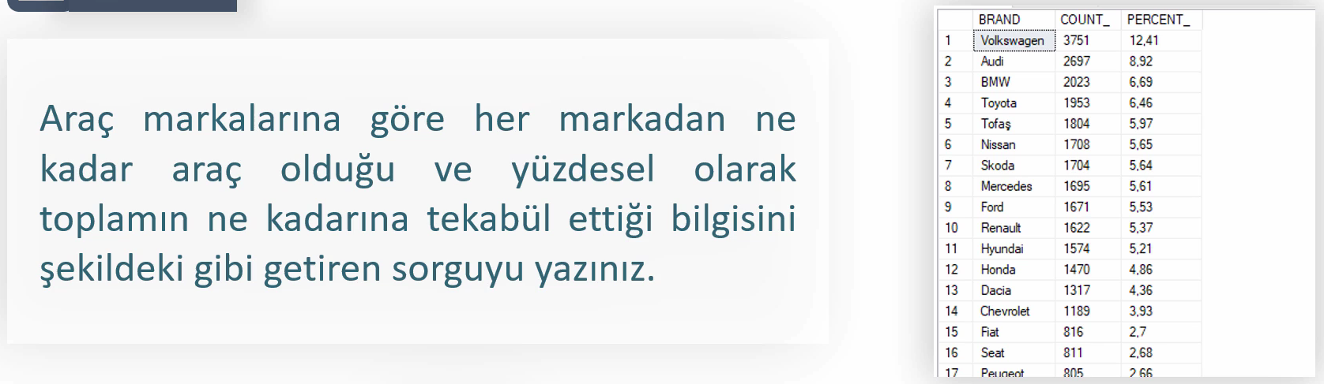

SELECT brand, count(*) as count,

round(convert(float,count(*))/(SELECT count(*) from WEBOFFERS)*100,2) as percentage

FROM WEBOFFERS

GROUP BY BRAND

ORDER BY 2 desc

#convert ile float’a çevirmezsen integer bölmesi yapıp sonucu 0 yapar.

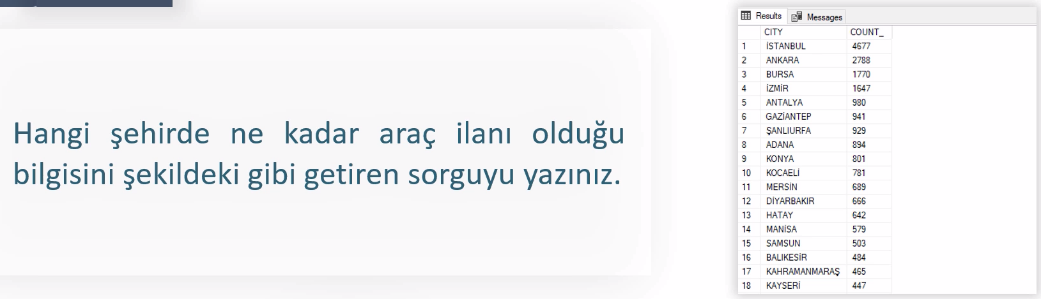

SELECT CITY,count(W.ID) AS count_

FROM WEBOFFERS W

JOIN CITY C ON C.ID=W.CITYID

GROUP BY CITY

order by 2 desc

2

SELECT CITY,(SELECT count(*) from WEBOFFERS WHERE CITYID=C.ID) AS count_

FROM CITY C

order by 2 desc

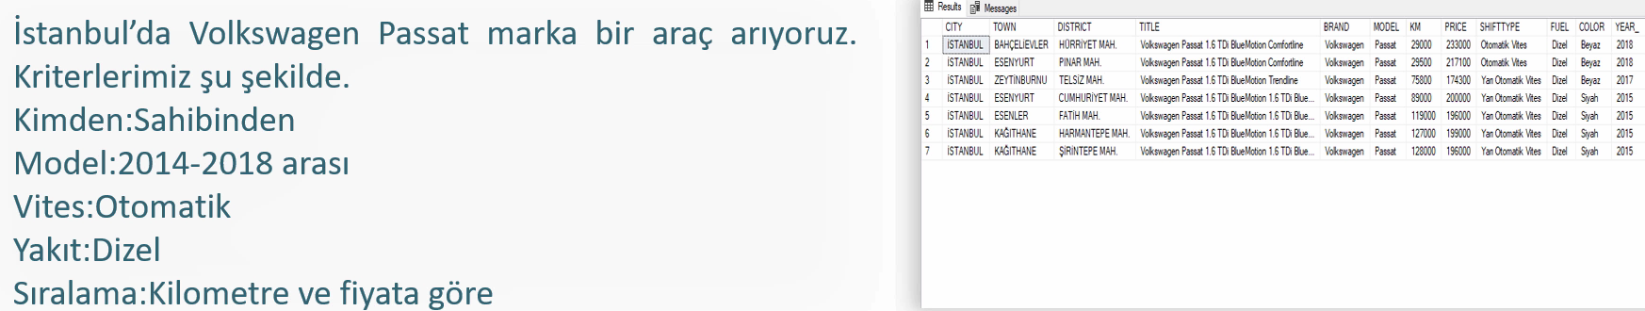

SELECT CITY, TOWN, DISTRICT, TITLE, BRAND, MODEL, KM, PRICE, SHIFTTYPE, FUEL, COLOR, YEAR_

FROM WEBOFFERS W

JOIN CITY C ON CITYID=C.ID

JOIN TOWN T ON TOWNID=T.ID

JOIN DISTRICT D ON DISTRICTID=D.ID

WHERE CITY='İSTANBUL'

AND BRAND='Volkswagen'

AND MODEL='Passat'

AND SHIFTTYPE IN ('Yarı Otomatik Vites','Otomatik Vites')

AND FROMWHO='Sahibinden'

AND YEAR_ BETWEEN 2014 AND 2018

AND FUEL='Dizel'

ORDER BY KM,PRICE

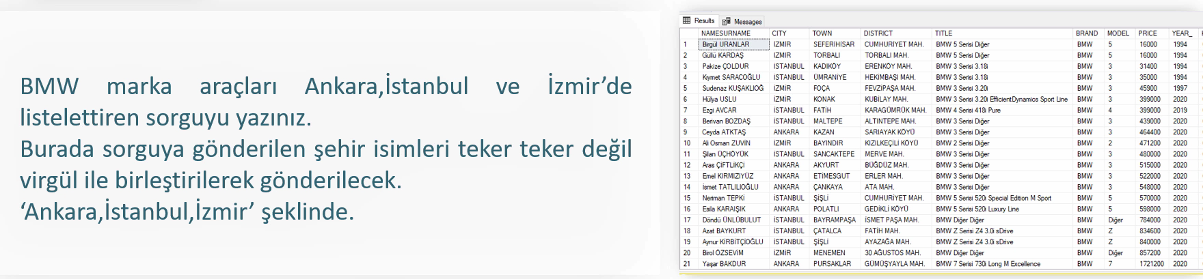

SELECT CITY, TOWN, DISTRICT, TITLE, BRAND, MODEL, KM, PRICE, SHIFTTYPE, FUEL, COLOR, YEAR_

FROM WEBOFFERS W

JOIN CITY C ON CITYID=C.ID

JOIN TOWN T ON TOWNID=T.ID

JOIN DISTRICT D ON DISTRICTID=D.ID

WHERE BRAND='Volkswagen'

AND CITY IN (SELECT value FROM string_split('ankara,istanbul,izmir',','))

AND COLOR IN (SELECT value FROM string_split('yeşil,mavi,kırmızı',','))

String_split ile yazacağın yere istenilen özellikleri tek metin halinde girebilirsin.

## SENARYO 5

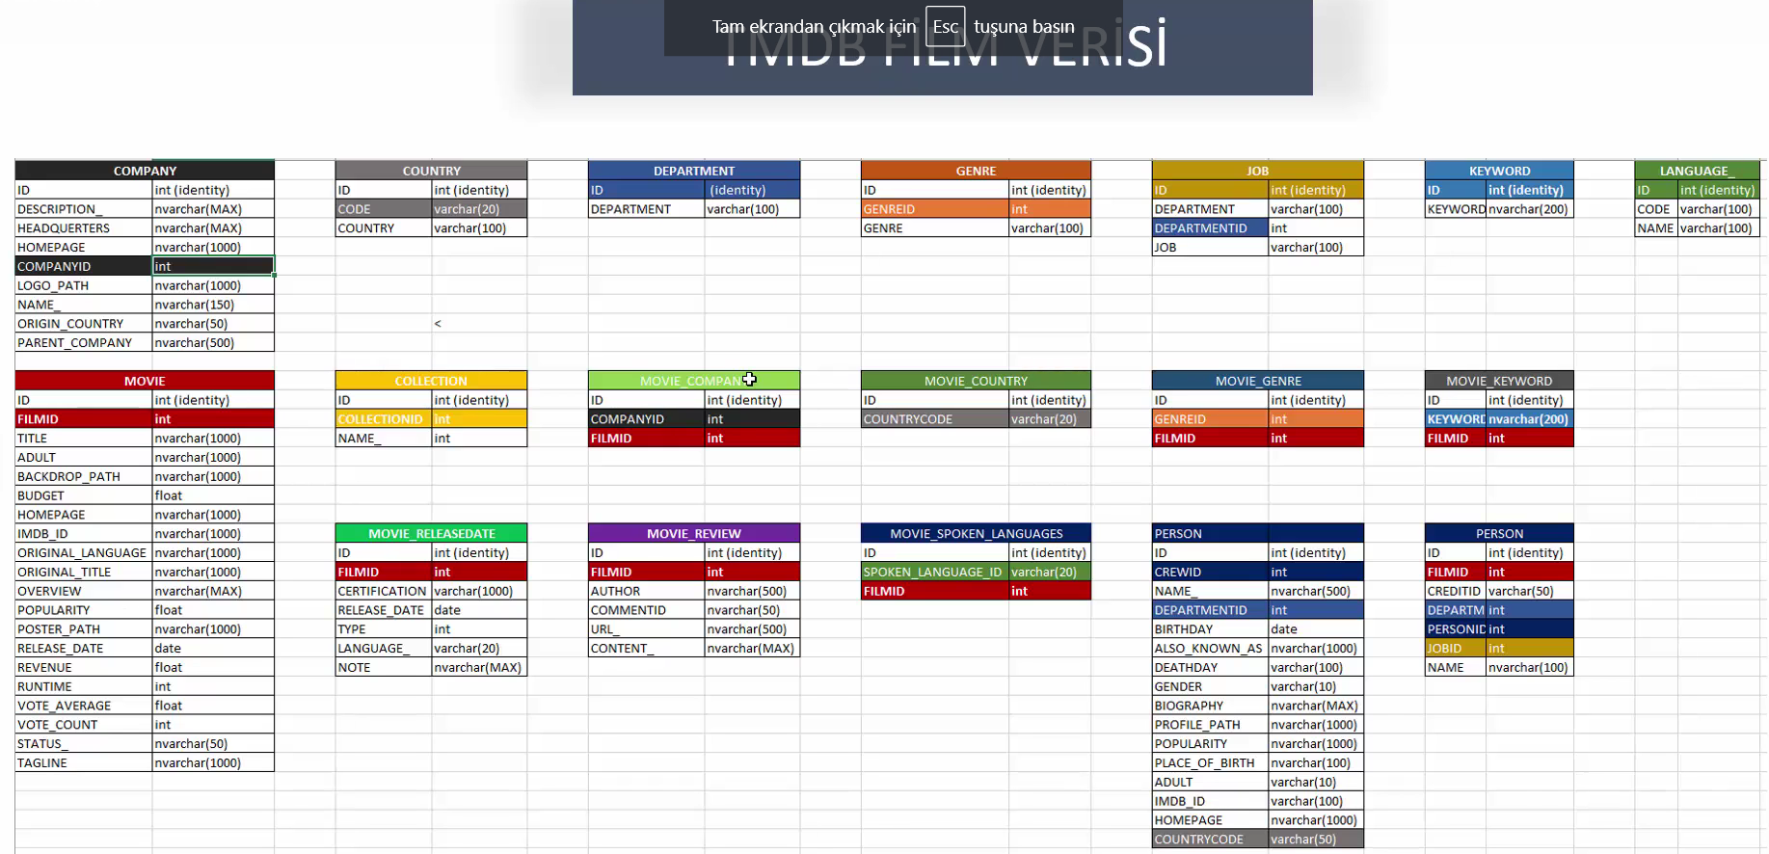

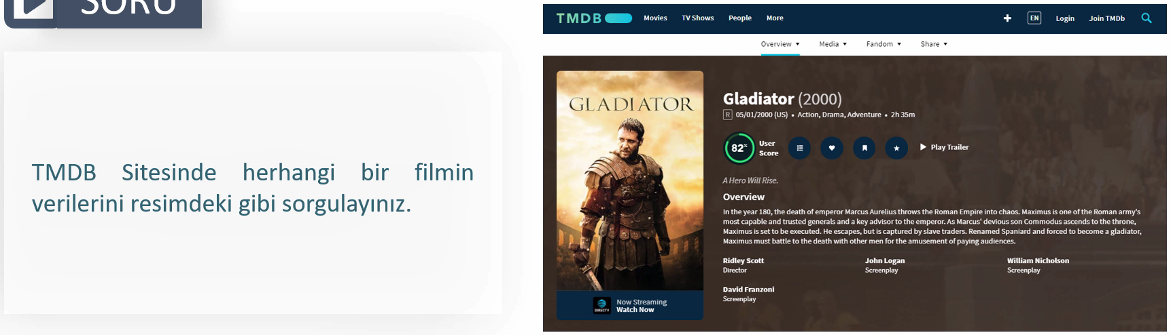



SELECT

TITLE + ' ('+ CONVERT(VARCHAR,YEAR(RELEASE_DATE)) + ')' as Title,

RELEASE_DATE,

CONVERT(VARCHAR,RUNTIME/60)+'h '+CONVERT(VARCHAR,RUNTIME%60)+'m' as Duration,

VOTE_AVERAGE*10 as Vote,

TAGLINE, OVERVIEW, POSTER_PATH,

(

SELECT GENRE+',' FROM MOVIE_GENRE MG

JOIN GENRE G ON G.GENREID=MG.GENREID

WHERE MG.FILMID=98

FOR XML PATH('') --Değerleri yan yana yazmak için

) as Genres

FROM MOVIE WHERE TITLE='Gladiator'

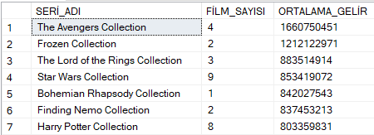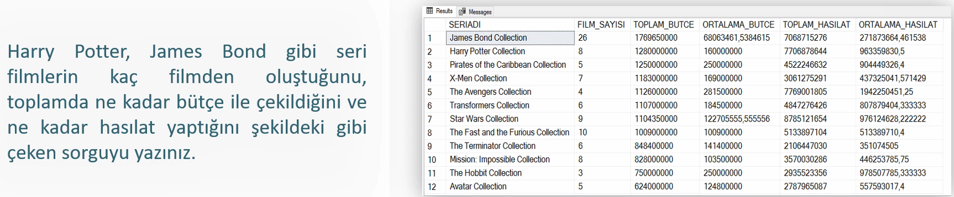

SELECT

NAME_ AS SERİ_ADI,

COUNT(M.FILMID) AS FİLM_SAYISI,

ROUND(AVG(REVENUE),0)-ROUND(AVG(BUDGET),0) AS ORTALAMA_GELİR

FROM COLLECTION_ C

JOIN MOVIE M ON M.COLLECTIONID=C.COLLECTIONID

GROUP BY NAME_

ORDER BY ORTALAMA_GELİR DESC

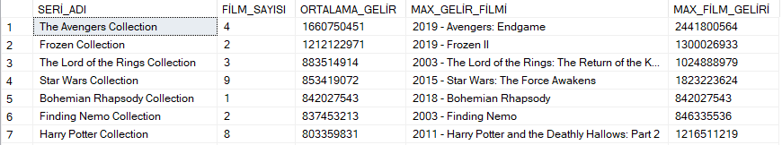

SELECT

NAME_ AS SERİ_ADI,

(SELECT COUNT(*) FROM MOVIE M WHERE M.COLLECTIONID=C.COLLECTIONID) AS FİLM_SAYISI,

(SELECT ROUND(AVG(REVENUE),0)-ROUND(AVG(BUDGET),0) FROM MOVIE M WHERE M.COLLECTIONID=C.COLLECTIONID) AS ORTALAMA_GELİR,

(SELECT TOP 1 CONVERT(VARCHAR,YEAR(RELEASE_DATE))+' - '+TITLE

FROM MOVIE M WHERE M.COLLECTIONID=C.COLLECTIONID ORDER BY (REVENUE-BUDGET) DESC) AS MAX_GELİR_FİLMİ,

(SELECT TOP 1 REVENUE-BUDGET

FROM MOVIE M WHERE M.COLLECTIONID=C.COLLECTIONID ORDER BY (REVENUE-BUDGET) DESC) AS MAX_FİLM_GELİRİ

FROM COLLECTION_ C

ORDER BY ORTALAMA_GELİR DESC

En az/ en çok şeklinde istenen yapıları Join ile getirmek zor. Bu sebeple sub-query kullanıyoruz.

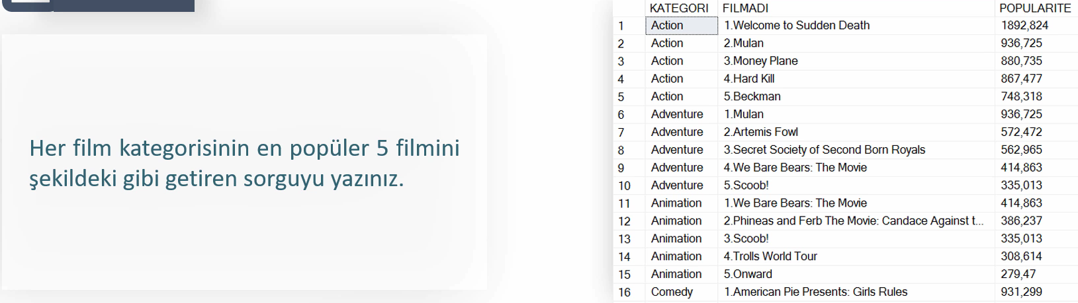

Önce sadece ‘Action’ için subquery yaptık.

SELECT TOP 5

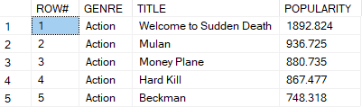ROW_NUMBER() OVER (ORDER BY POPULARITY DESC) AS ROW#,

GENRE,TITLE,POPULARITY

FROM MOVIE_GENRE MG

JOIN GENRE G ON MG.GENREID=G.GENREID

JOIN MOVIE M ON MG.FILMID=M.FILMID

WHERE G.GENRE='Action'

ORDER BY POPULARITY DESC

Sonrasında bunu tüm tabloya uyarladık.

SELECT GN.GENRE, CONVERT(VARCHAR,MV.ROW#)+'.'+MV.TITLE AS MOVIE, MV.POPULARITY

FROM GENRE GN

CROSS APPLY(

SELECT TOP 5

ROW_NUMBER() OVER (ORDER BY POPULARITY DESC) AS ROW#,

GENRE,TITLE,POPULARITY

FROM MOVIE_GENRE MG

JOIN GENRE G ON MG.GENREID=G.GENREID

JOIN MOVIE M ON MG.FILMID=M.FILMID

WHERE GN.GENREID=G.GENREID

ORDER BY POPULARITY DESC) MV

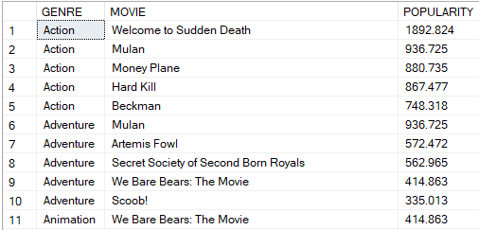Numaranlandırmadan arınmış hali:

SELECT GN.GENRE, TITLE AS MOVIE, MV.POPULARITY

FROM GENRE GN

CROSS APPLY(

SELECT TOP 5

GENRE,TITLE,POPULARITY

FROM MOVIE_GENRE MG

JOIN GENRE G ON MG.GENREID=G.GENREID

JOIN MOVIE M ON MG.FILMID=M.FILMID

WHERE GN.GENREID=G.GENREID

ORDER BY POPULARITY DESC) MV